Food contact gears from

HPC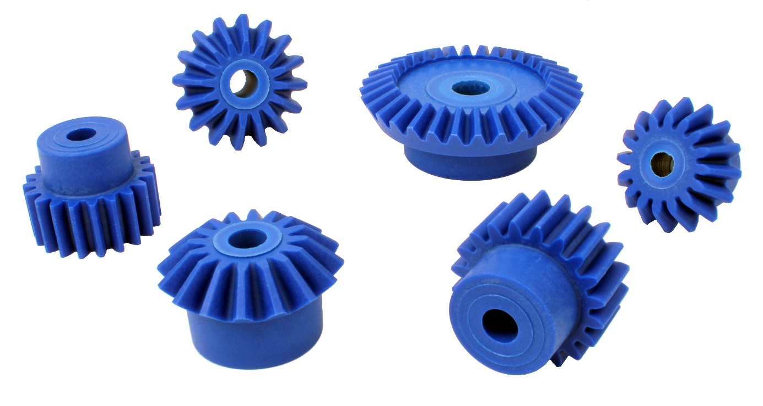

In order to increase the number of products suitable for use in the food industry, Engrenages HPC has added an innovative new range of gears to its catalogue. Both spur and bevel gears are available and these are made of polyamide reinforced with glass fibres and suitable for contact with food.
The blue gears are perfect for use in food processing machines where the distinctive colour makes it possible to quickly identify any component parts that may have inadvertently fallen into the whatever is being processed by this type of machine.
The range of bevel gears starts with 16 teeth and with ratios from 1:1 to 3:1. Spur gears start with 12 teeth and are available from modules from 0.5 to 3.

